Report by: 1409046  
Role: Level Design & Artist liaison

Game Version: Latest – with Menus  
Date Reported: 04/05/2016

QA Status: Passed

Severity: Major

Priority: High

Test Introduction:

The purpose of this test was to check that the end zone registered that the player had reached the finish line, to test this I placed the player right in front of the end zone and let it go through the middle portal.

Expected outcome:

I expected the ship to go through the portal and a win canvas to come up giving the play the option to play again r go to the main menu.

Actual outcome:

When the ship went through the portal there was no canvas displayed.

Screenshot of the bug:

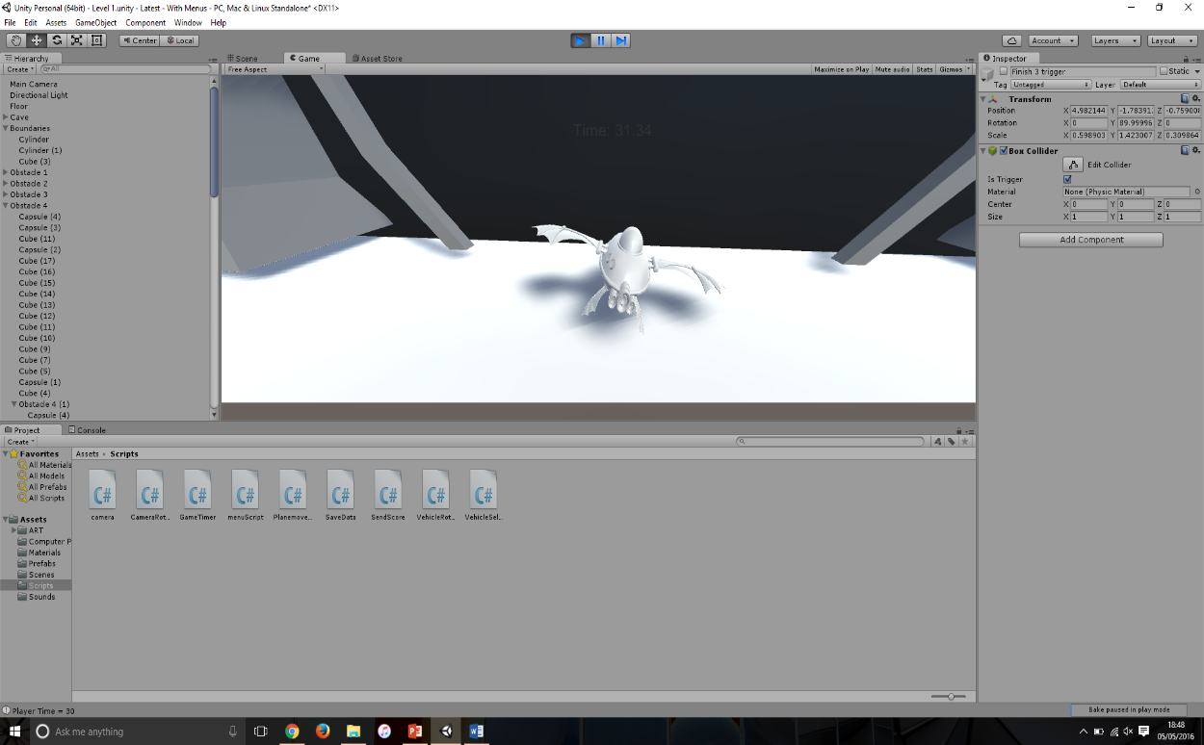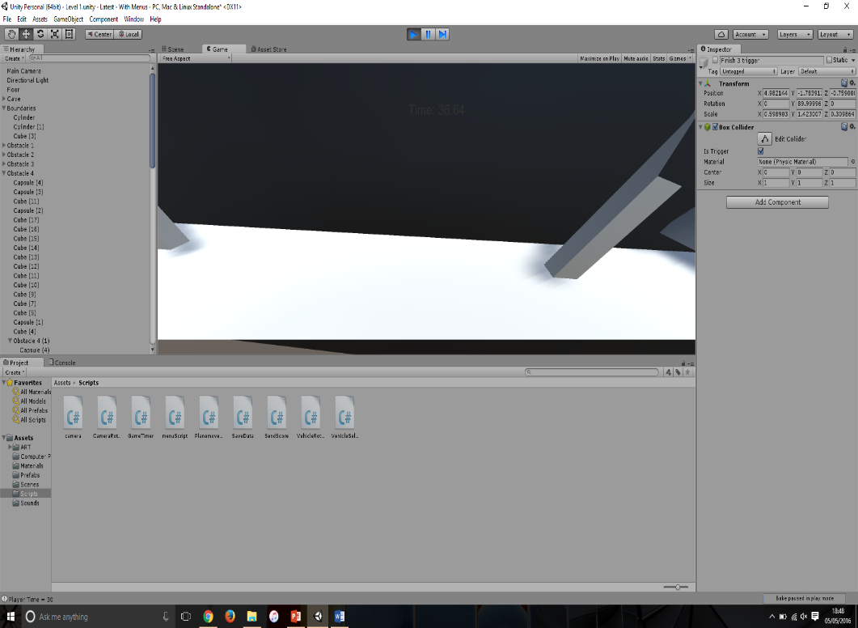

Image showing the ship going though portal with no canvas being displayed

Potential cause:

A potential cause for this bug could be that the segment of code that brings up the canvas isn’t in the right position and the code never calls the canvas to the screen. E.g. placed in death state.

Another cause for this bug could be that the trigger for collider that the win state is attached to isn’t turned on.

Suggested Fix:

To fix this bug the trigger for the collider had to be turned on.